The Impact Ranking
SGD 3 Good health and Well Being
3.3 Collaborations and health services
3.3.6 Does your university as a body have a "smoke-free" policy?
Air University
Policy – Smoke Free
(To be read in conjunction with ZEV)
General
1. Air University is dedicated in creating a smoke-free atmosphere that is also pleasant, safe, and healthy for its students, teachers, staff, and visitors. It focuses in identifying the presence of any inflammable or toxic materials inside the building which may be hazardous to human health resulting on an unhealthy atmosphere and untreatable diseases.
Main Purpose & Objectives
2. The purpose of this policy is to enable the University to honor its commitment in managing a smoke-free campus in a befitting manner. To achieve this, following restrictions are imposed at all university-managed property, both indoor and outdoor.
- Smoking is not permitted in any buildings, classrooms, auditoriums, barracks, residential halls, labs, libraries, offices, reception, boardrooms, lobbies, corridors, stairs and café etc.
- In order to make smoking illegal inside university property, there will be notices of NO SMOKING must be pasted at each building's entrance and in other sensitive and important areas.
- At all areas belonging to the university , tobacco and sedative products or items connected to smoking are not allowed to be used, shared or sell.
- No free samples of tabacco or other smoking related items are allowed to be shared , distributed or sell off.
- Companies that actively produce tobacco or encourage smoking are not allowed to sponsor university events, job fairs or any other gatherings.
- No publicity or marketing is allowed of Tabaco items.
- Any incident of smoking must be reported to relevant stakeholders for appropriate action.

Compliance

3. All occupants of the university are expected to ensure compliance to No Smoking or generation of smoke through any means. Waste papers will not be burnt rather will be shredded and disposed off to designated areas.
Employees
4. Noncompliance to this policy will be taken very seriously and will lead to punitive action by department or management for remedial action.
Students
5. Students who deviates university code of conduct will be reported to the appropriate authority for punishment and may result into expulsion from university.
Responsibility

6. All university occupants, including faculty, staff, students, volunteers, etc., must abide by this policy. All members' courtesy, respect, and cooperation are necessary for this policy to be carried out effectively. If this policy is repeatedly violated, it may result in disciplinary action according to the relevant staff or student code of conduct.

.Distribution

7. This policy will be shared with all departments, faculty, students, vendors, contractors, and newly engaged workers. It will also be made public in a number of university publications, portals and websites.

- Air University and FMC (including PAF hospital) is a smoke free facility. There is a strict policy regarding smoking and drugs on campus. Violation of this policy is subject to fine of Rs. 1000 and stern disciplinary action. This policy is applicable to students, staff and visitors.

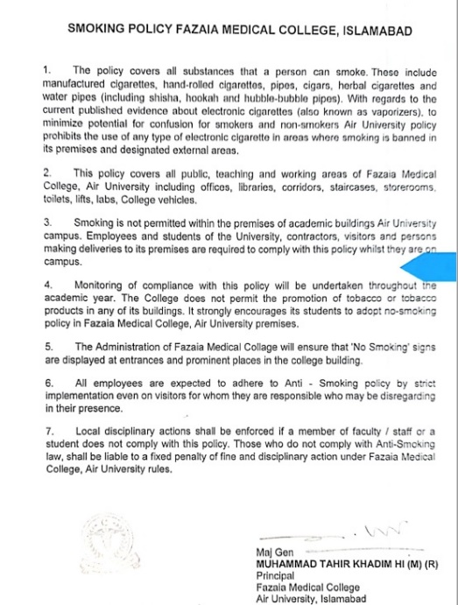

Policy created (yyyy)
Policy reviewed (yyyy)

